Documentation of Azure infrastructure

We’ll document on 4 tools, Azure SQL Database, Azure Data Lake Storage, Azure Data Factory, Databricks Community edition

Azure SQL Database:

It’s an SQL Database built on top of the latest MSSQL & made in the Azure infrastructure, enabling different advanced features like vectorized search, retrieval augmented generation (RAG) support & so on, provides the hyperscale ( flexible scalable database as a service ) serverless hyperscale architecture that lets you spin up as many databases & compute as possible.

Features like hyperscale, copilot, AI ready data, integration with Microsoft Fabric & the whole microsoft ecosystem.
The purchasing model is based on either DTU ( database transaction unit ), this bundles CPU/IO/Mem usage into one unit,or using virtual cores V-Core based billing,

For more info on how to create a azure sql database follow this tutorial

Azure Data Lake:
Azure Data lake makes it easy for devs, data scientist & analyst to store data of any size & shape, it removes the complexities of ingesting & storing all of your data while making it faster to to get up & running with batch, streaming & interactive analytics; you can use the data lake analytics or hd insight which cloud apache spark & hadoop on the azure infrastructure; there’s also data lake store which can store unlimited data lakes that power big data analytics.

Azure data lake storage is a set of capabilities dedicated to big data analytics built on top of Azure blob storage; providing file system like semantics file level security & scale since they’re built on top of the blob storage, designed from the start to serve the petabytes of data, this make Azure data lake storage the foundation for building enterprise data lakes on Azure.
Data lake is a repo to store data either structured or unstructured, which enables the organizations to quickly & easily store,access & analyze a wide variety of data in a single location.
Azure data lake storage is a set of capabilities that you use with the blob storage service of your storage Azure account, it includes different capabilities like hadoop compatible access, hierarchical directory structures, optimized cost & performance, finer grain security model & massive scalability…

For detailed guide follow this tutorial

Azure Data Factory

Brief Azure Cloud Screenshot

Azure SQL Database
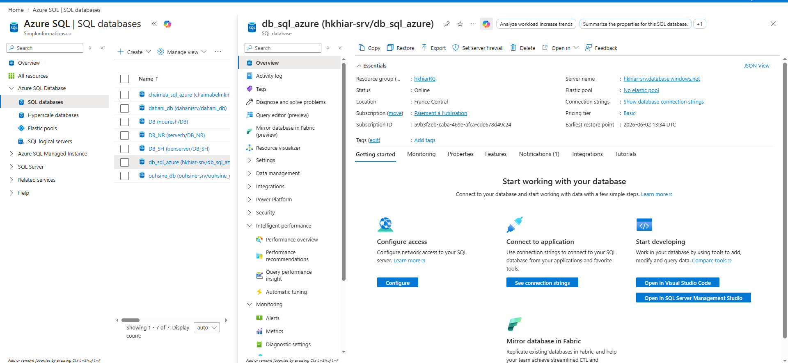

Azure Data Lake
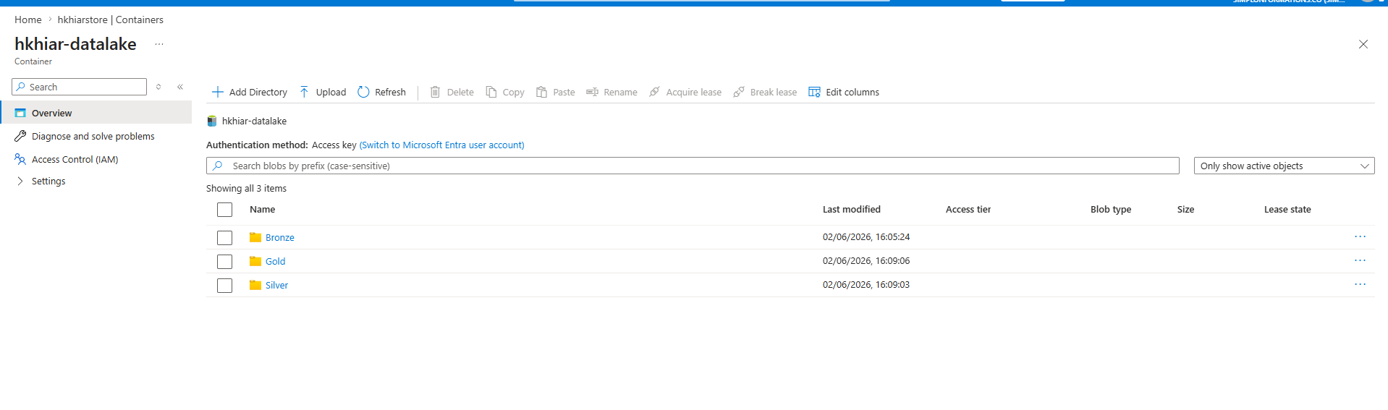

Azure Data Factory:
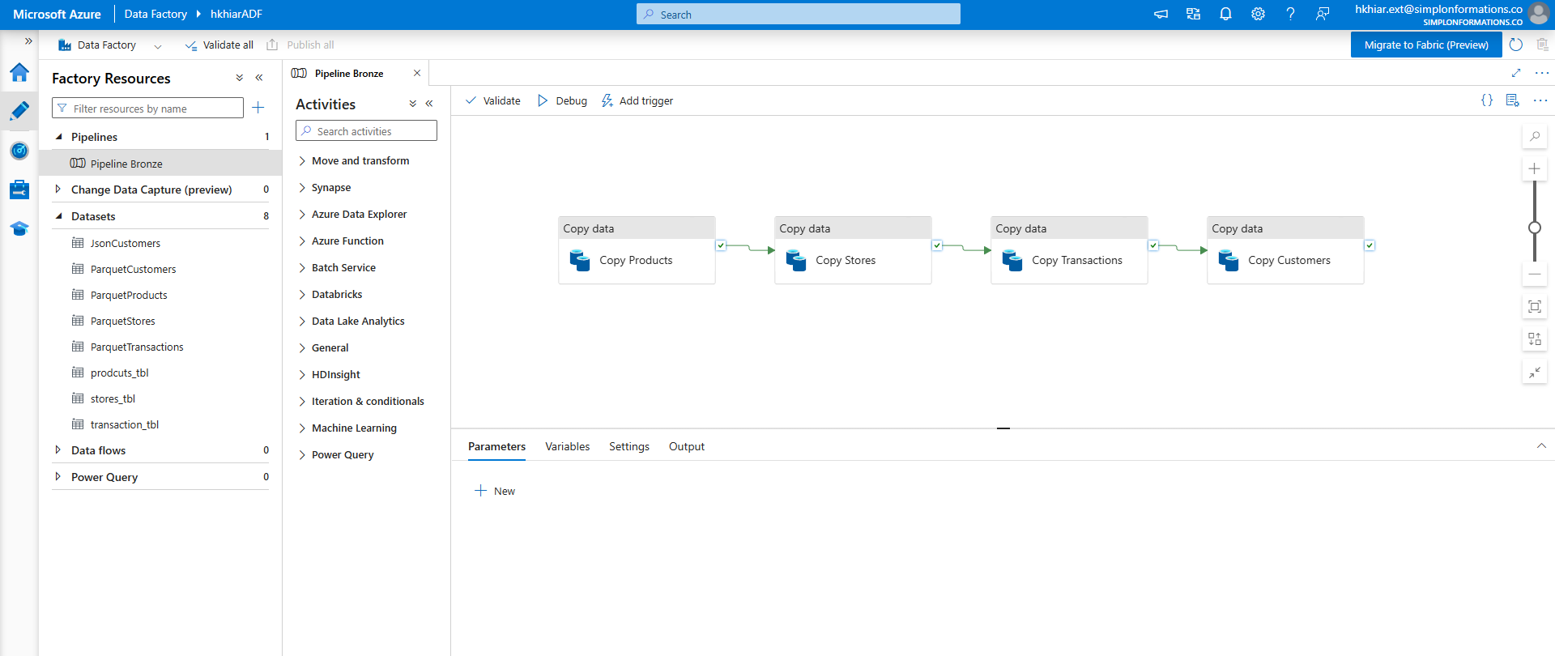

DataBricks:
The code I have in data bricks documenting both from bronze to silver & silver to gold
Here’s the link

